**Personal Portfolio Template**

Group 28

Nicholas Gaffney – n8618828

<https://github.com/gaffnni/IFB299_TuttingTrumpets>

**Artefact 1** – Database Design(ERD)

This artefact is showing the design/entity relationship diagram of the MySQL database that will contain and organise all the data related to the database. This diagram shows not only all the tables required and their columns/data stored in them, but most importantly the relationships between these tables. This design was come up with between myself and Tim Jebsen over several weeks of discussion and analysing the requirements agreed to and user stories generated from those requirements.

This diagram was not only used and refined to ensure complete coverage of each the requirements set by the client. It is also a critical and integral part in the writing of the SQL query that will create the tables and subsequent relationships between those tables. Attempting to do this without such a diagram would lead to gaps in either the required tables or the relationships and thus take significantly longer to implement as required.

This design is shown below. A higher definition image can be found in the Artefact 1 folder.

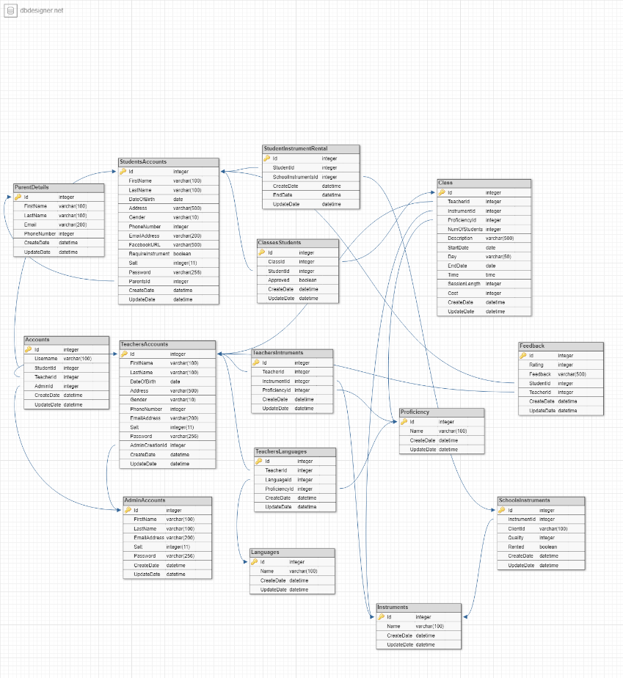

**Artefact 2** – Database Creation SQL

This artefact is the portion of SQL code that generates and creates all the relations between each of the tables required for the website to operate. This query first outlines all the tables and the columns with the typing and whether that column can be null or not. It also sets the Id of each table to be its primary key and to be automatically incrementally generated. The foreign keys/relationships between these tables are then implemented by altering the tables that have previously been generated.

This MySQL database will act as the backbone and main repository for the website containing all the account, class, instrumental rental information. This database will mostly be interacted with via the PHP that is present in the website. Any action that is taken by the website that involves the retrieval or creation of information will result in a call to this database. The SQL queries used by the PHP code to interact with the database are laid out in Artefact 3.

A sample of this code is shown below. To see the complete query examine the file ‘PinelandMusicSchool_TableCreation.sql’ in Artefact 2.

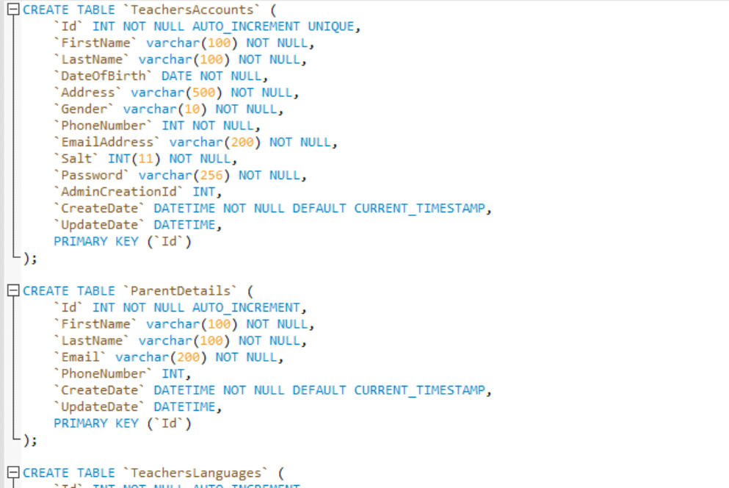

**Artefact 3** – Database Stored Procedures

The extensive list of SQL queries found in Artefact 3 are all used to communicate between the database and the website either by returning, inserting or deleting data from one or multiple tables. Each one of these queries represents one action taken by the website, for example creating an account, viewing a class, etc. As such each query is relatively simple in its execution, however due to the number of actions the website has to be able to take there is quite a number of them, the number of which is likely to increase in order to achieve the requirements for sprint 2.

As there can be several issues when developing a website when it comes to database PHP interactions these were developed against a local copy of the database used by the website. This allows for these queries to be developed and checked for any possible SQL errors such as syntax or returning misinformation. Another step to make the designing of these interactions easier was to ensure the queries were all designed to take in either string or int values given from the website. These are simple datatypes that will transformed into the complicated datatypes (e.g. datetime) used by the database.

The query to check a valid login request is shown below. To see the other queries built examine the files in Artefact 3.

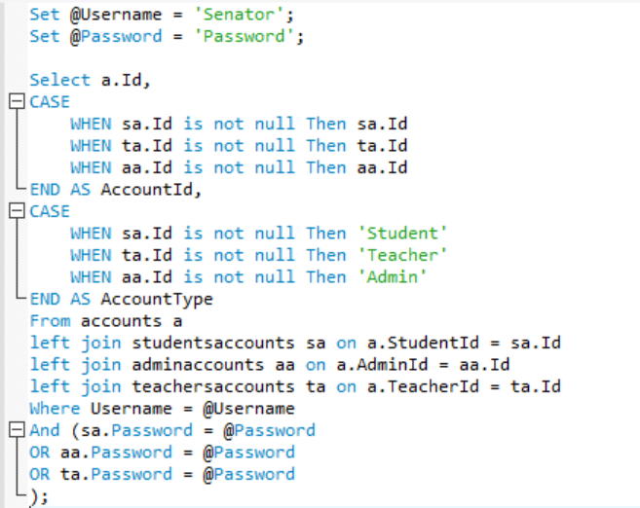

**Artefact 4** – Component Diagram(General User)

(Description about what the artefact is in general)

…

(Brief description of how it was used/contribution to the project)

…

(Screen capture of where it’s used)

...

…

**Artefact 5** – Data Flow(Student)

(Description about what the artefact is in general)

…

(Brief description of how it was used/contribution to the project)

…

(Screen capture of where it’s used)

...

…